**Image Understanding HW1** 43688514Jia-Wei, Chiang

**A: Matlab Warmup**

**1. Describe the result of each of the following Matlab commands.**

1. >>x=randperm(5)

Set x to a vector which contains 5 random permutation elements from 1 to 5  
Example: x may be set to [1 3 5 2 4]

1. >> a = [1 2 3;4 5 6;7 8 9];   
   >> b = a(2,:);

Set a to a 3 times 3 vector which the first row is 1, 2, 3 and the second is 4, 5, 6, and the last row is 7, 8, 9.Set b to an vector which contains the second row of matrix a. The answer is [4 5 6].

1. >> f = [1501:2000];   
   >> g = find(f > 1850);   
   >> h = f(g);

Set f to a vector with elements from 1501 to 2000 in ascending order and the stepsize is 1. Set g to a vector that contains the indices of elements in f which are greater than 1850.  
Set h to a vector that contains the elements in f which are indexed by g.  
Result f: [1501 1502 1503 … 2000], g: [351 352 353 … 500], h: [1851 1852 1853 … 2000]

1. >> x = 22.*ones(1,10);   
   >> y = sum(x);

Set x to be a 1*10 matrix (row vector) of ones and all elements multiply 22.  
Set y to be the sum of all elements in x.

Result x: [22 22 22 22 22 22 22 22 22 22], y: 220

1. >> a = [1:100];   
   >> b = a([end:-1:1]);

Set a to a vector with elements from 1 to 100 in ascending order and the stepsize is 1.Set b to a vector with elements from the last element of a to the first element of a in descending order and interval is 1.  
Result a: [1 2 3 … 100], b: [100 99 98 … 1]

**2.(a) Reshape the intensities stored in *A* into a single 10,000-dimensional vector *x*, sort the values in *x* and plot the values**

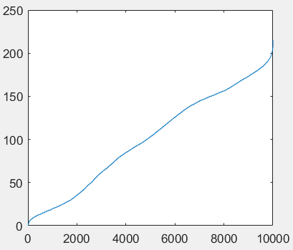

**2.(b) Display a figure showing a histogram of *A*'s intensities with 32 bins using the *hist* function**

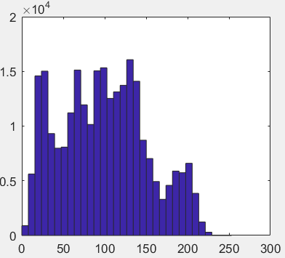

**2.(c) Create and display a new binary image the same size as *A*, which is white wherever the intensity in A is greater than a threshold *t*, and black everywhere else.**



**2.(d) Display the bottom right quadrant of *A***



**2.(e) Generate a new image (matrix), which is the same as *A*, but with *A*'s mean intensity value subtracted from each pixel. Set any negative values to 0**

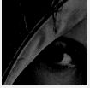

**2.(f) Display the mirror-flipped version of image A**

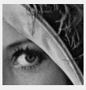

**2.(g) Use the *min* and *find* functions to set *x* to the single minimum value that occurs in *A*, and set *r* to the row it occurs in and *c* to the column it occurs in**

Minimum value x = 0

Find 9 pixels have same value: (81,1), (40,4), (53,20), (47,23), (37,26), (38, 26), (42, 27), (34, 33), (33, 35).

**2.(h) Let *v* be the vector: v = [1 8 8 2 1 3 9 8]. Use the *unique* function to compute the total number of unique values that occur in *v***

The total number of unique values that occur in v is 5.

**B: Computing average images**

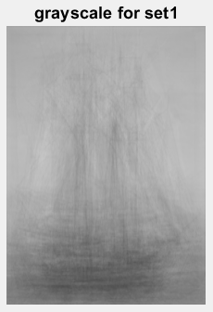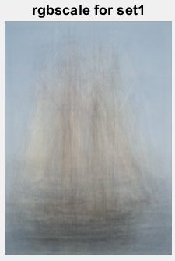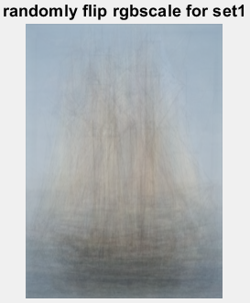

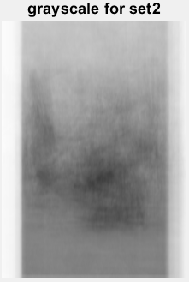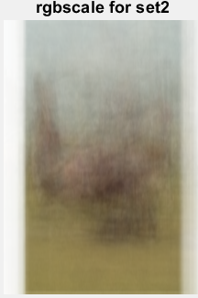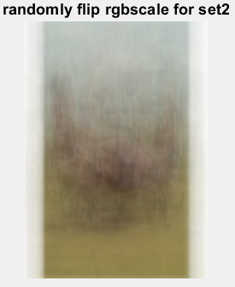

The average images show rough contour of pictures. The random mirror-flip average image looks blurrier than regular RGB scale, because half of them is flipped, which have less features.

### C: Image classification

### display the first airplane in the test set

### 

### 3. Compute a class confusion matrix

### 

### average classification rate: 0.3539

**4. Construct a KNN-classifier that computes the K closest training images, and returns the most common label from this set**

### k=1, average missclassification rate: 0.6461, most common label: 4

### k=3, average missclassification rate: 0.6697, most common label: 2

### k=5, average missclassification rate: 0.6602, most common label: 4

### k=1 has the best average misclassification.

### 

### 5. KNN-classifier with normalized correlation

### k=1, average missclassification rate: 0.58, most common label: 8

### k=3, average missclassification rate: 0.5837, most common label: 0

### k=5, average missclassification rate: 0.5642, most common label: 0

### With normalized correlation, k=5 has the best average misclassification.

### 

### 6. What is your best-performing system? Provide some explanation as to why you think this combination performed best

### My best-performing system is using normalized correlation with KNN-classifier k=5. Correlation Distance subtracts the mean value from all the pixels, it balances the lighting condition in data set.

### 

The images showing above are horses but misclassifying as deer because their similar contour.